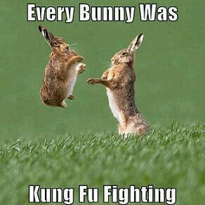
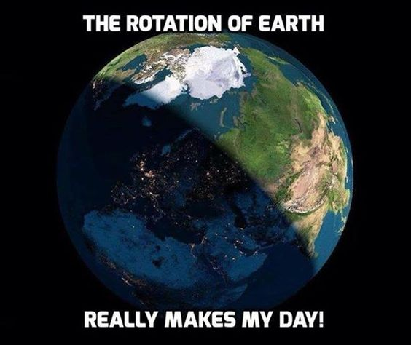
ELA to-do April 22-26
- Read to Self
  - Reread “Black Cowboy, Wild Horses”
  - Complete inference sheet for Black Cowboy
  - Read “Nat Love” Leveled Reader
  - On the back of inference sheet, write 4 facts about Nat Love that you think are cool
- Technology
  - Create a google slides presentation about Nat Love and black cowboys (w/ group)
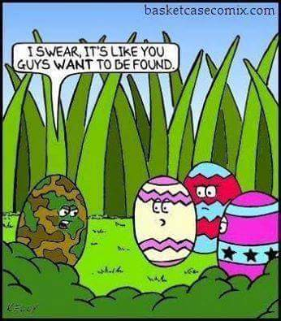
- Writing
  - Finish writing pages (Due Friday)
  - Begin pictures (at least ½ done)
- Word Work
  - 1 spelling practice method
  - 5 sentences with spelling words
  - Label parts of speech or diagram those sentences
  - 5 words from thesaurus (from spelling list)

ELA to-do April 22-26
- Read to Self
  - Reread “Black Cowboy, Wild Horses”
  - Complete inference sheet for Black Cowboy
  - Read “Nat Love” Leveled Reader
  - On the back of inference sheet, write 4 facts about Nat Love that you think are cool
- Technology
  - Create a google slides presentation about Nat Love and black cowboys (w/ group)
- Writing
  - Finish writing pages (Due Friday)
  - Begin pictures (at least ½ done)
- Word Work
  - 1 spelling practice method
  - 5 sentences with spelling words
  - Label parts of speech or diagram those sentences
  - 5 words from thesaurus (from spelling list)

